..............................................

**Challenge 2**

..............................................

**Challenge link-->** <http://www.pythonchallenge.com/pc/def/ocr.html>

An image is displayed:

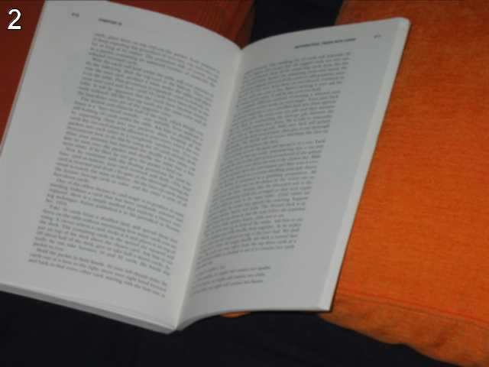

Hint is: " **recognize the characters. maybe they are in the book, but MAYBE they are in the page source**. "

From hint we get to know that we have to look into page source code:

<http://www.pythonchallenge.com/pc/def/ocr.html>

There are two comments:

<!--

find rare characters in the mess below:

-->

and 2nd one is some very long text!!!!!

In the first comment it highlights "find rare characters"

We can find frequency of each characters to find the rare ones.

I wrote a python code (challenge_2.py) to find frequency of each characters and found that along with these special characters, there are few alphabets which occur only once.

Simply means these are the rare characters which was mentioned in the first comment.

After joining all the alphabets, I got the word to move to next challenge.